Running Container in Interactive mode

Python Program To be Run in Container: -
python program to print the sum of two user-defined numbers:
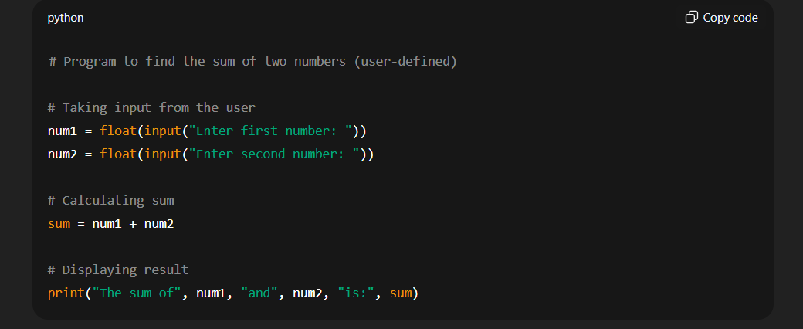

Output: -
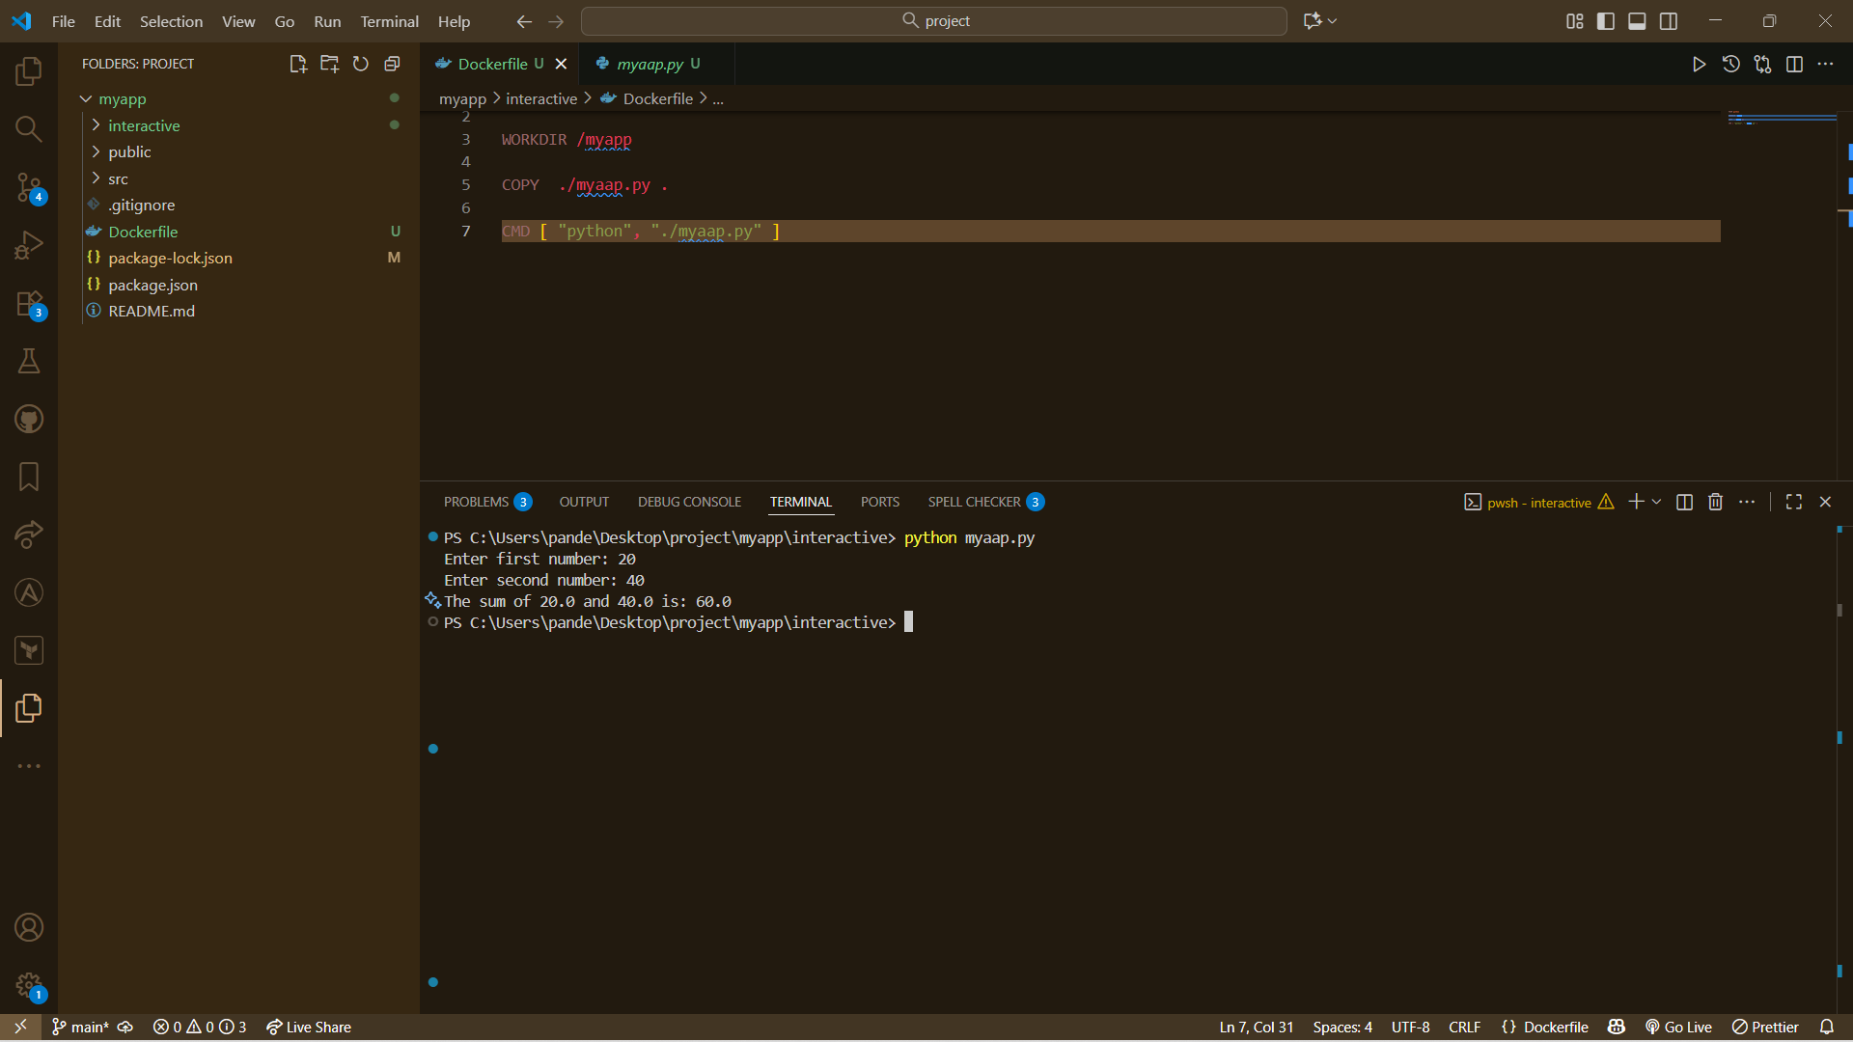

Create Docker File: -
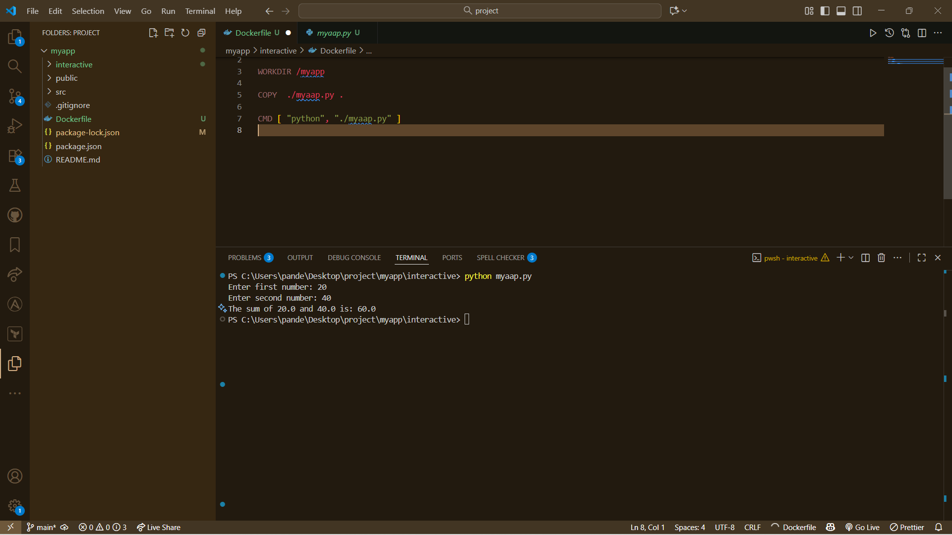

Now, Create Docker Image: -
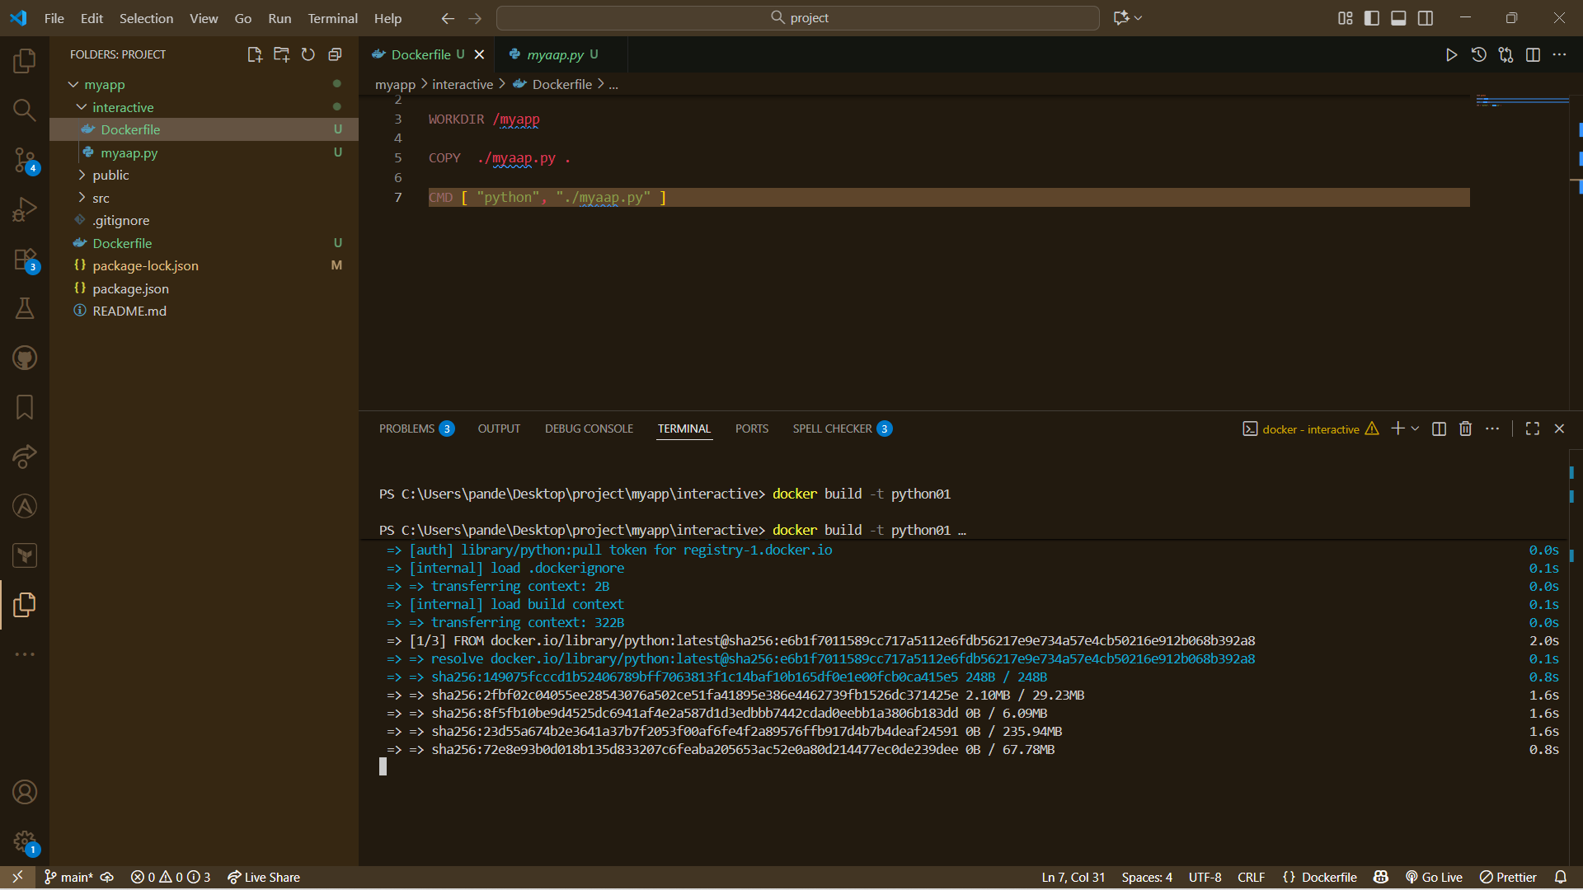

Created Docker Image: -
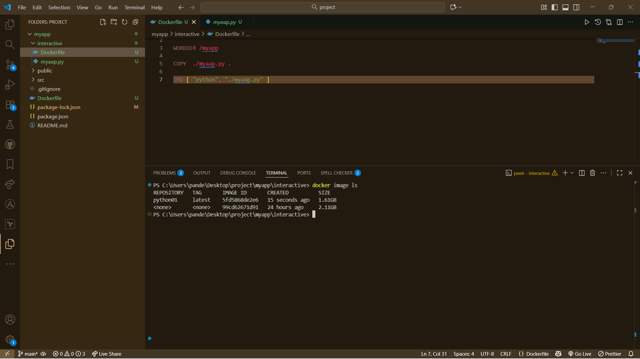
Name: - python01

Run a Container without Interactive Mode: -
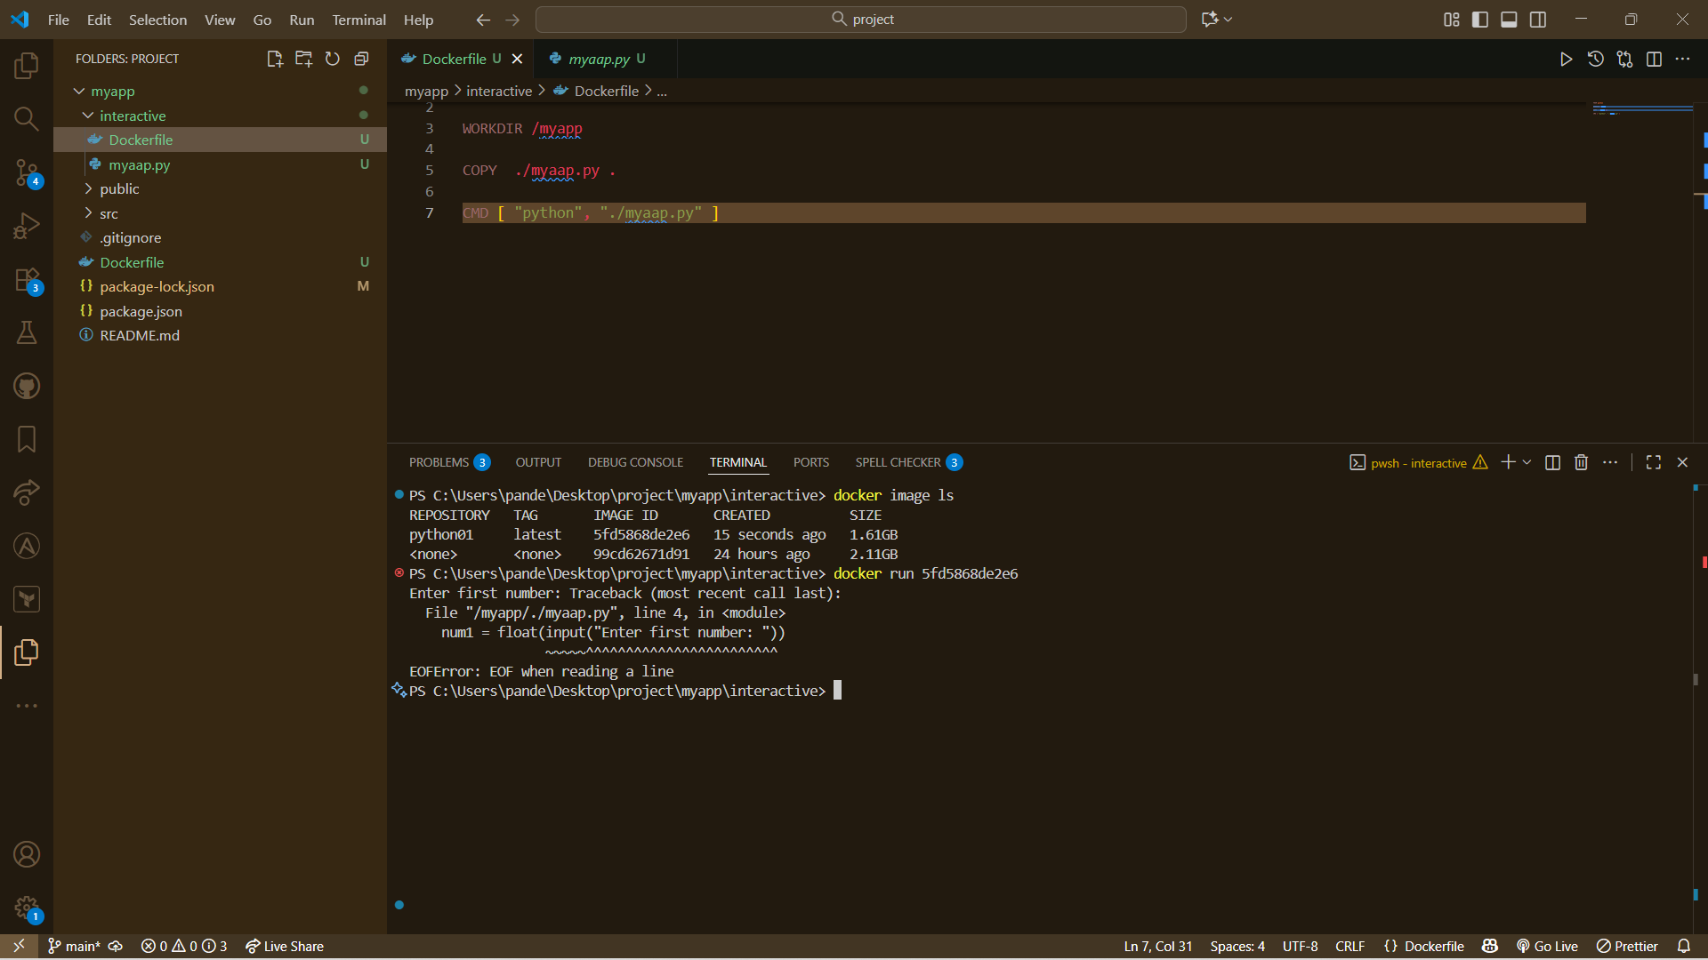
Command: - Docker run image_id
Run a Container in Interactive Mode: -
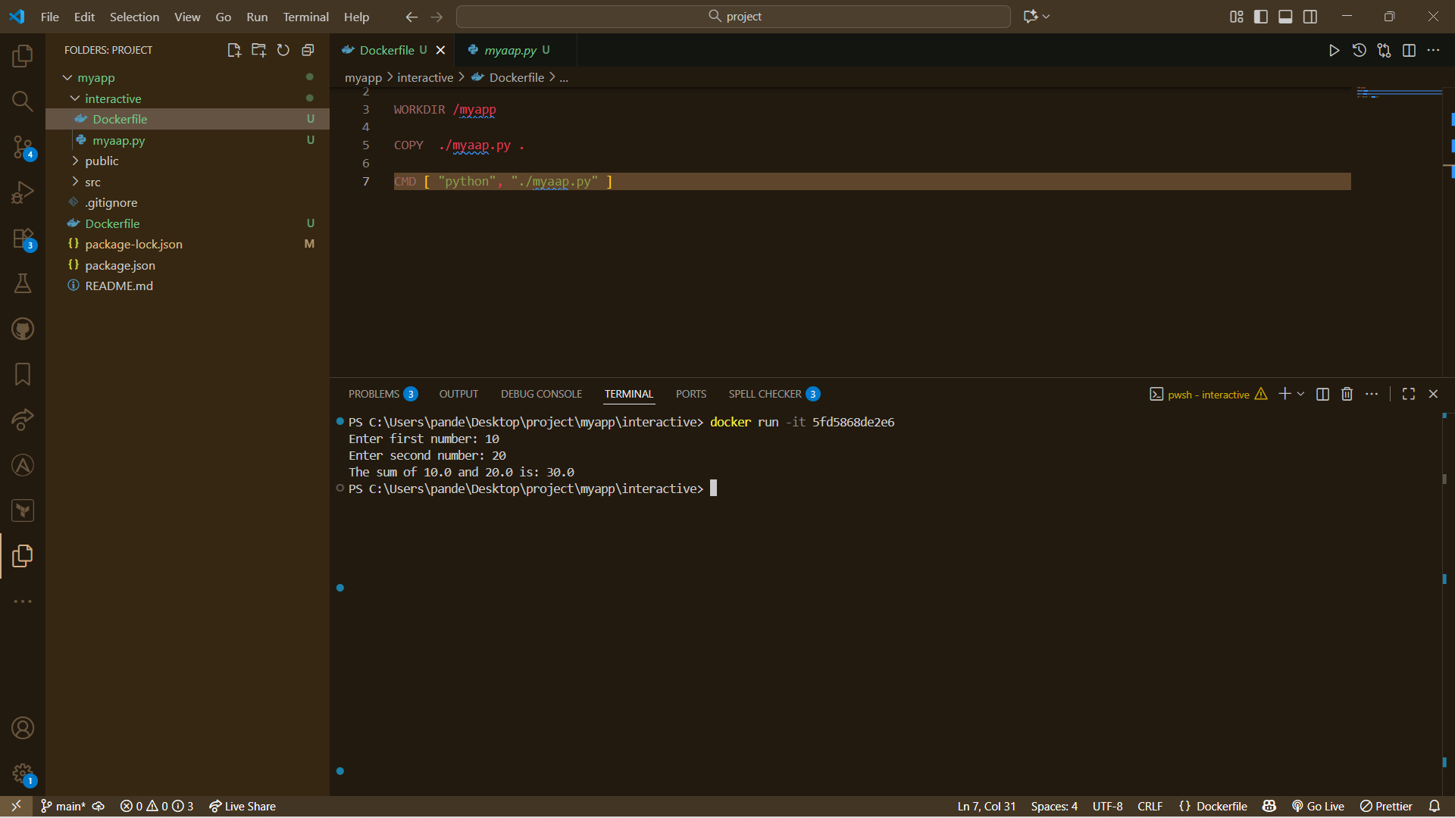
Command: - Docker run -it image_id

Docker Desktop: -
Images: -
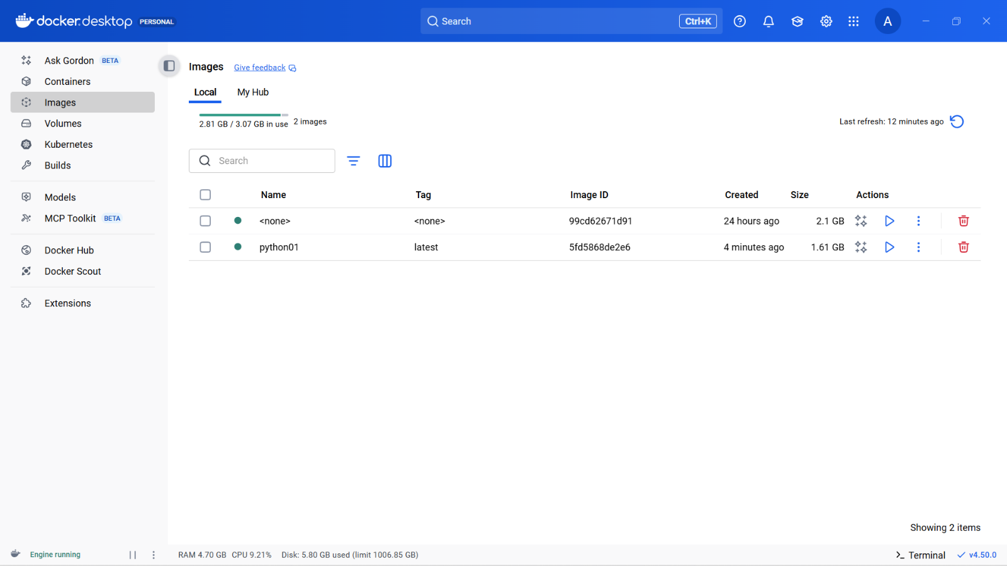

Container: -

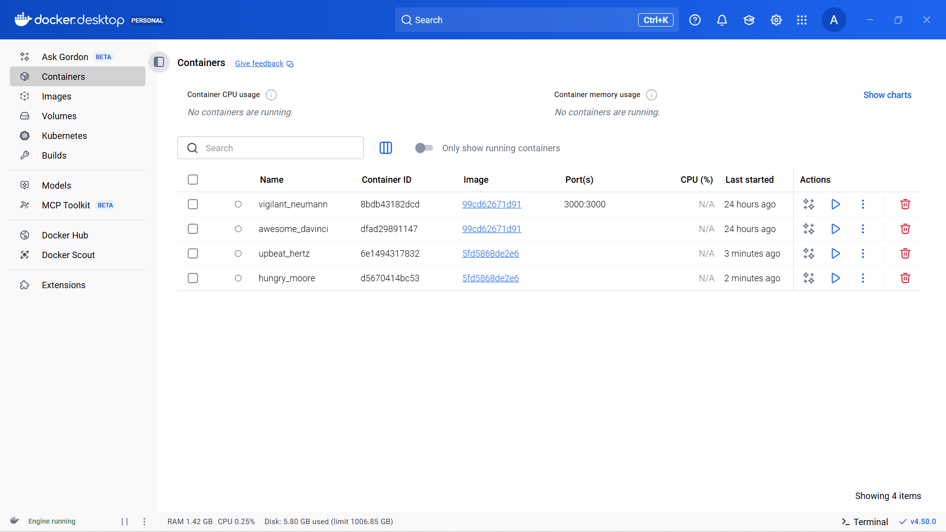

See last two Container….

-----------------------------------------------------------------------------------------------------------------------------------------------------------

